Contact: Gerald W. Haney  Grayson Utilities Commission  Phone 606.474.7569  Cell 606.316.6805 | 671 South State Hwy 7  Grayson, KY 41143  Phone 606.474.7569  Fax 606.474.2662 | Grayson Utilities Commission
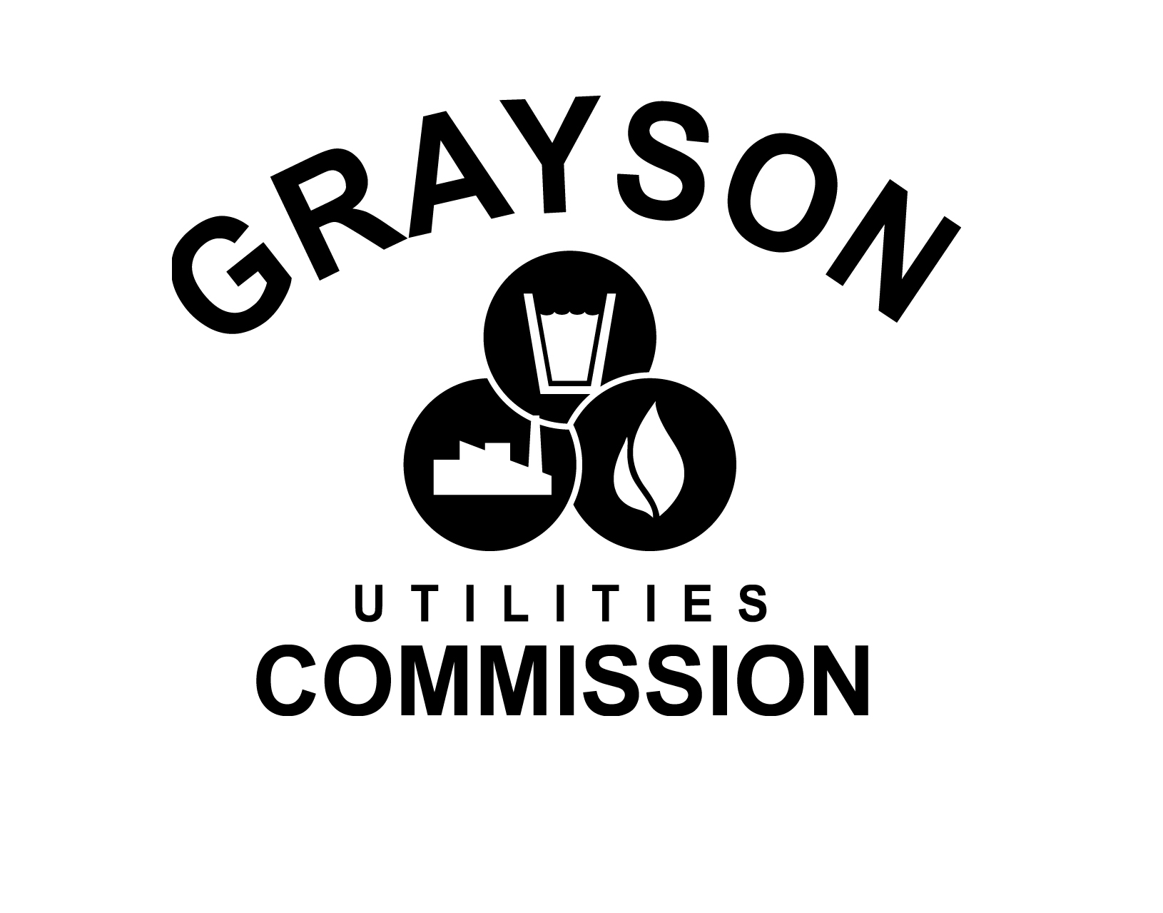 Press Release
Grayson Utilities urges sewer customer’s to keep “flushable” wipes out of public sewer
Grayson, KY, March 10, 2011: The past few years have seen the introduction of more and more disposable wipe products for a variety of household uses. Many of these products are labeled as not only disposable, but also flushable, but unlike toilet paper these products don’t break down once they are flushed. While marketed as convenience items, these products may potentially become a huge inconvenience because they may clog not only the sewer on your property, but also cause blockages and backup problems in Grayson’s public sewer system and Lift stations.

To understand how these wipes can become a problem, it’s important to know how the sewer system works. Every home has a sewer connection that runs from the home to the public sewer system. This sewer service line is the responsibility of the homeowner to maintain so there are no backups of wastewater into the home. From there, the sewage moves into larger collector lines, and pump stations help lift the wastewater across different elevations in the sewer system until it reaches its final destination at the wastewater treatment plant.

Why are household wipes a problem? Unlike toilet paper, these products don’t break down once they are flushed. They can then cause blockages in your home sewer lines, especially in older pipelines that may already have existing grease, roots or other obstructions, resulting in the backup of sewage into the home. A repair of the service line can leave the homeowner with a nasty repair bill – often not covered by homeowner’s insurance - and an even nastier cleanup.

On a larger scale, when these products make their way into the public sewer system, they collect together and cause clogs in the collector lines and get tangled in lift station pumps. When pumps stations are clogged, they stop working and require cleaning and repair – or even replacement – in order to get the sewage moving again. The expenses can be very costly and could eventually lead to increases in sewage rates to all customers.

Avoid a nasty cleanup in your home and help protect the city’s sewer system by never flushing any consumer items that is not toilet paper into the sewer system, regardless of what the packaging promises.

Put these items in the trash instead:
- Diapers
- Disinfecting wipes or baby wipes
- Cotton swabs
- Toilet cleaning pads
- Mop refills
- Paper towels
- Moist towelettes
- Shop towels
- Feminine hygiene products

The Grayson Utilities Commission recommends placing disposable wipes in the garbage, and not in the toilet. Flushable wipes could take years or decades to break down in the system. Please refer to this Consumer Reports Video :
(http://video.consumerreports.org/services/player/bcpid1886192484?bctid=22783507001)

Regarding flushable wipes.

When in doubt, don’t flush! For more information, contact Grayson Utilities Commission at 606.474.7569.

